9.89: a)
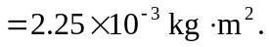
b) See Example 9.9. In this case,
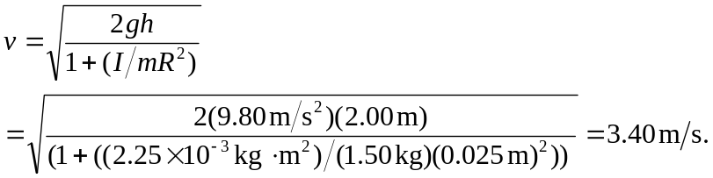
c) The same calculation, with  instead of  gives 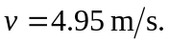 This does make sense, because for a given total energy, the disk combination will have a larger fraction of the kinetic energy with the string of the larger radius, and with this larger fraction, the disk combination must be moving faster.

